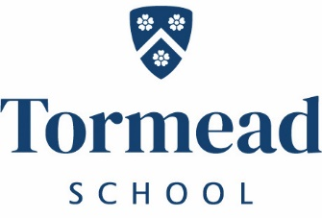
Tormead
KS2 Teacher
(Two Terms)
Required January 2022
An enthusiastic and well qualified teacher is sought to teach KS2 classes at Tormead Junior School. Applications are invited from newly qualified and experienced teachers.
Tormead has its own salary scale.
All staff are expected to make a contribution to the extra-curricular life of the School.
To apply for this role please complete the application and equal opportunities form found on the website along with an accompanying letter addressed to Mrs Nicki Fry (Head of Pre-Prep) and send to recruitment@tormeadschool.org.uk
Closing date: 8th November 2021, we reserve the right to close the vacancy early should the right candidate be found.
It is anticipated that interviews will take place w/c 8th November 2021
Tormead School is committed to the safeguarding and welfare of its pupils and all staff must share this commitment. Applicants must be willing to undergo an enhanced DBS check and other Child Protection screening including checks with past employers. The post holder must adhere to the School’s Child Protection Policy at all times including attending mandatory training every three years.
Independent Day School for Girls 4-18 years
Tormead School, Cranley Road,
Guildford, Surrey GU1 2JD
www.tormeadschool.org.uk
A member of The Girls Schools Association (GSA)

