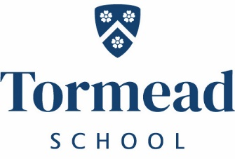
Tormead
Music Teacher
Full Time
Required January 2022 – April 2022
An enthusiastic and well-qualified Music teacher is sought to teach across all year groups up to A level. This is an exciting opportunity for an experienced teacher or a new entrant to the profession.

Tormead has its own salary scale.
To apply for this role please complete the application and equal opportunities form found on the website along with an accompanying letter addressed to Mr David Boyd (Head) and send to recruitment@tormeadschool.org.uk
Closing date: 4pm Wednesday 3rd November 2021
Tormead School is committed to the safeguarding and welfare of its pupils and all staff must share this commitment. Applicants must be willing to undergo an enhanced DBS check and other Child Protection screening including checks with past employers. The post holder must adhere to the School’s Child Protection Policy at all times including attending mandatory training every three years.
Independent Day School for Girls 4-18 years
Tormead School, Cranley Road,
Guildford, Surrey GU1 2JD
www.tormeadschool.org.uk
A member of The Girls Schools Association (GSA)

