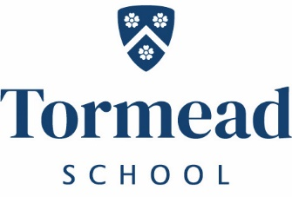
Tormead
Physics Teacher
Full Time
Required January 2022 for two terms with possibility of extension.
An enthusiastic and well-qualified Physics teacher is sought to teach across all year groups. This is an exciting opportunity for a new entrant to the profession, or for an experienced teacher Tormead has its own salary scale.
To apply for this role please complete the application and equal opportunities form found on the website along with an accompanying letter addressed to Mr David Boyd (Head) and send to recruitment@tormeadschool.org.uk
Closing date: Wednesday 3rd November 2021 and interviews will take place the following week.
Tormead School is committed to the safeguarding and welfare of its pupils and all staff must share this commitment. Applicants must be willing to undergo an enhanced DBS check and other Child Protection screening including checks with past employers. The post holder must adhere to the School’s Child Protection Policy at all times including attending mandatory training every three years.
Independent Day School for Girls 4-18 years
Tormead School, Cranley Road,
Guildford, Surrey GU1 2JD
www.tormeadschool.org.uk
A member of The Girls Schools Association (GSA)

